Web pages

Definition:
# Source: AI Source: Provided by: [Data Path: Persons Table -> ID Column: 1, Name_En Column: Motasem Essam] -> From: [Chatgpt (GPT‑5 Mini)] on [2/12/2026]
A web page is a single document on the internet that is part of a website. It is what you see in your browser when you visit a website.

Simple Definition
# Source: AI Source: Provided by: [Data Path: Persons Table -> ID Column: 1, Name_En Column: Motasem Essam] -> From: [Chatgpt (GPT‑5 Mini)] on [2/12/2026]
Web page = one page of a website, made of text, images, videos, and links.

How Web Pages Work
# Source: AI Source: Provided by: [Data Path: Persons Table -> ID Column: 1, Name_En Column: Motasem Essam] -> From: [Chatgpt (GPT‑5 Mini)] on [2/12/2026]
- Written in HTML (structure)
- Styled with CSS (design, colors, layout)
- Made interactive with JavaScript (buttons, forms, animations)
- Stored on a web server and accessed via a web browser

Examples of Web Pages
# Source: AI Source: Provided by: [Data Path: Persons Table -> ID Column: 1, Name_En Column: Motasem Essam] -> From: [Chatgpt (GPT‑5 Mini)] on [2/12/2026]
- Home page of a website
- About page (“About Us”)
- Contact page
- Blog post or article page
- Product page on an online store

Difference Between Web Page and Website
# Source: AI Source: Provided by: [Data Path: Persons Table -> ID Column: 1, Name_En Column: Motasem Essam] -> From: [Chatgpt (GPT‑5 Mini)] on [2/12/2026]
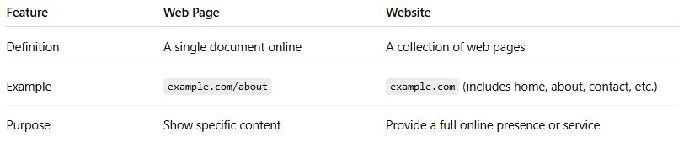
Feature | Web Page | Website
Definition | A single document online | A collection of web pages
Example | example.com/about | example.com (includes home, about, contact, etc.)
Purpose | Show specific content | Provide a full online presence or service

Key Points
# Source: AI Source: Provided by: [Data Path: Persons Table -> ID Column: 1, Name_En Column: Motasem Essam] -> From: [Chatgpt (GPT‑5 Mini)] on [2/12/2026]
- A website is made of multiple web pages
- Each page has a unique URL
- Web pages can include text, images, videos, links, and interactive elements

Types of Web Pages
# Source: AI Source: Provided by: [Data Path: Persons Table -> ID Column: 1, Name_En Column: Motasem Essam] -> From: [Chatgpt (GPT‑5 Mini)] on [2/12/2026]
1. Home Page
- The main page of a website.
- Introduces the site and guides users to other pages.
- Example: example.com

2. About Page
- Provides information about a person, company, or organization.
- Example: example.com/about

3. Contact Page
- Contains contact information, forms, or maps.
- Example: example.com/contact

4. Landing Page
- A standalone page designed for marketing or a specific goal, like signing up for a newsletter or buying a product.
- Example: Promotional page for a product

5. Blog / Article Page
- Displays articles, tutorials, or news.
- Example: example.com/blog/how-to-learn-coding

6. Product / Service Page
- Shows details about a product or service, often with pricing, images, and purchase options.
- Example: E-commerce product pages

7. Portfolio Page
- Highlights work, projects, or achievements.
- Example: Graphic designer’s project showcase

8. Gallery Page
- Displays images, videos, or multimedia content in a structured way.
- Example: Photographer’s gallery

9. FAQ Page
- Lists frequently asked questions with answers.
- Helps users get quick information.

10. Login / Registration Page
- Allows users to create an account or sign in to access private content or services.

11. Error Page (404 Page)
- Appears when a user tries to visit a page that doesn’t exist.

12. Checkout / Payment Page
- Used in e-commerce sites for completing purchases.

13. Search Page
• Allows users to look for specific content, products, or information on a website using keywords or filters.
• Example: Searching for “red shoes” on an e-commerce site.

14. Dashboard Page
• Provides a centralized overview of important information, data, or tools, often in a visual and interactive format.
• Example: Admin panel showing user stats, recent activity, and charts.

Summary Table
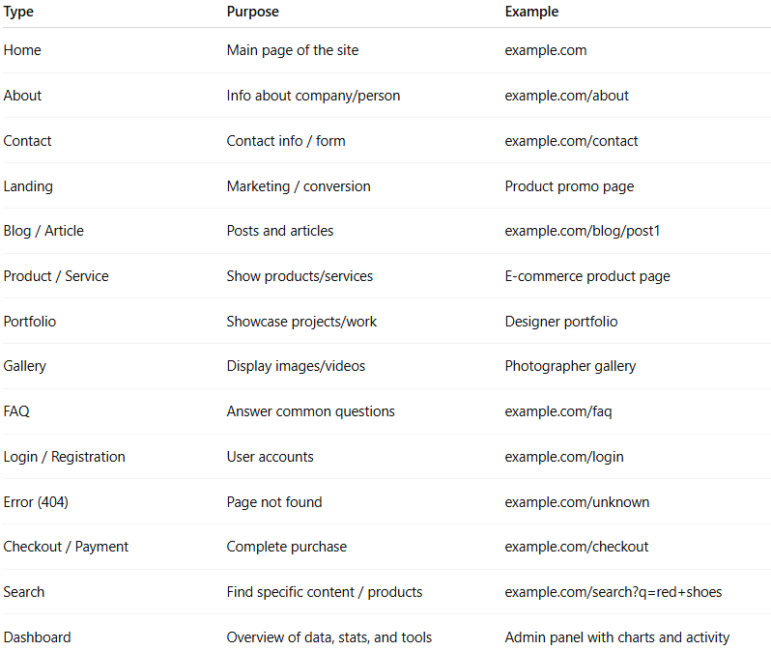
Type | Purpose | Example
Home | Main page of the site | example.com
About | Info about company/person | example.com/about
Contact | Contact info / form | example.com/contact
Landing | Marketing / conversion | Product promo page
Blog / Article | Posts and articles | example.com/blog/post1
Product / Service | Show products/services | E-commerce product page
Portfolio | Showcase projects/work | Designer portfolio
Gallery | Display images/videos | Photographer gallery
FAQ | Answer common questions | example.com/faq
Login / Registration | User accounts | example.com/login
Error (404) | Page not found | example.com/unknown
Checkout / Payment | Complete purchase | example.com/checkout
Search | Find specific content / products | example.com/search?q=red+shoes
Dashboard | Overview of data, stats, and tools | Admin panel with charts and activity

Types of Web Page Components
# Source: AI Source: Provided by: [Data Path: Persons Table -> ID Column: 1, Name_En Column: Motasem Essam] -> From: [Chatgpt (GPT‑5 Mini)] on [2/12/2026]
- Header
  - Usually at the top of the page
  - Contains the logo, site name, and main navigation menu
  - Example: Website logo + menu links
- Navigation Menu / Navbar
  - Helps users move between different pages of the website
  - Example: Home, About, Contact links
- Main Content / Body
  - The core information of the page
  - Could be text, articles, product details, videos, or images
  - Example: Blog post content, product description
- Sidebar (optional)
  - Secondary content placed to the side of the main content
  - Example: Popular posts, advertisements, categories
- Footer
  - Found at the bottom of the page
  - Contains copyright info, links, contact info, social media icons
  - Example: © 2026 Company Name, Privacy Policy, Facebook link
- Images / Multimedia
  - Pictures, videos, animations, or sliders to enhance content
  - Example: Product images, photo gallery
- Buttons / Call-to-Action (CTA)
  - Interactive elements that prompt users to take action
  - Example: “Buy Now,” “Sign Up,” “Learn More”
- Forms
  - Allow users to input information
  - Example: Contact forms, registration forms, search bars
- Links
  - Navigate to other pages or external websites
  - Example: “Read more” links in a blog
- Widgets / Plugins (optional)
  - Extra functionality like calendars, social feeds, or maps
  - Example: Embedded Google Map, Twitter feed
- Typography / Text
  - Headings, paragraphs, lists, quotes, etc.
  - Example: <h1> for headings, <p> for paragraphs
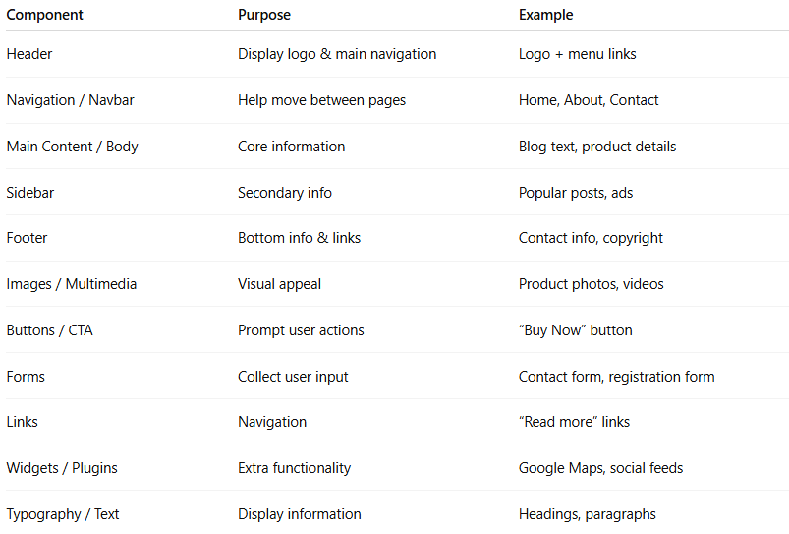
Component | Purpose | Example
Header | Display logo & main navigation | Logo + menu links
Navigation / Navbar | Help move between pages | Home, About, Contact
Main Content / Body | Core information | Blog text, product details
Sidebar | Secondary info | Popular posts, ads
Footer | Bottom info & links | Contact info, copyright
Images / Multimedia | Visual appeal | Product photos, videos
Buttons / CTA | Prompt user actions | “Buy Now” button
Forms | Collect user input | Contact form, registration form
Links | Navigation | “Read more” links
Widgets / Plugins | Extra functionality | Google Maps, social feeds
Typography / Text | Display information | Headings, paragraphs

